**LEBANESE AMERICAN UNIVERSITY**

**USAID – HIGHER EDUCATION SCHOLARSHIP PROGRAM**

**HES - Volunteering Program Verification Form**

This form is to be used to document volunteering hours. If a student volunteers for multiple organizations, a separate form must be used for each organization. **This form must be turned in by the 28th of each month, the latest.**

I certify that the scholar Elham Shadi Diab completed a total of 30 hours of service at InnovaThrive.

The hours were completed hours as per the below:

Hours # 10 (date) _4/11 – 8/11_ (initials of supervisor) __A.K.___

Hours # 10 (date) _11/11 – 15/11_ (initials of supervisor) __A.K.___

Hours # 5 date) _18/11 – 22/11 (initials of supervisor) __A.K.___

Hours # 5 date) _25/11 - 29/11 (initials of supervisor) __A.K.___

Brief description of the activities the scholar performed or participated in:

I worked as a moderator, I did 5 tasks . Task 1: research: The role of AI in enhancing diagnostic accuracy in healthcare. Task2: Defi:The future of Banking. Task 3: The Role of AI in Enhancing Workplace Productivity . Task4: The Impact of Virtual Reality on Education and Training

Written feedback about the scholar’s performance:

Elham’s extensive work as a research moderator reflects her leadership and multitasking capabilities. Her diverse research topics demonstrate her versatility and ability to manage complex projects with precision.

Please rate the overall performance of the scholar at your organization:

|  |  |  |  |
| --- | --- | --- | --- |
|  | Mastery (5) | Proficient (3) | Emerging (1) |
| **Problem solver** | X |  |  |
| **Engaged & Committed** | X |  |  |
| **Open-minded & multicultural** | X |  |  |

Signature

& stamp

__________________________

_

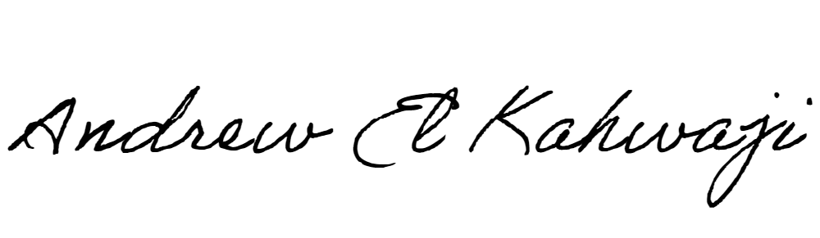

Printed Name _Andrew El Kahwaji_

Date __26/11/2024___

Email __andrew.lifesculptor.coo@gmail.com __

Phone __+961 71 914 378__

**LEBANESE AMERICAN UNIVERSITY**

**USAID – HIGHER EDUCATION SCHOLARSHIP PROGRAM**

